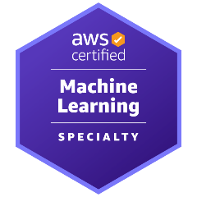
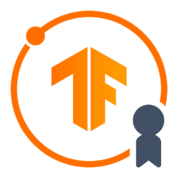
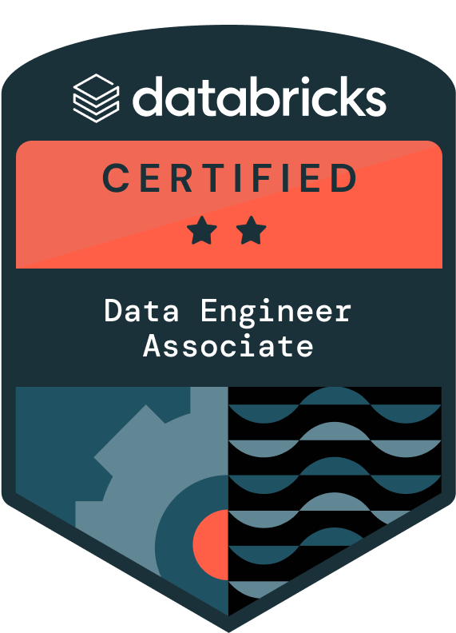
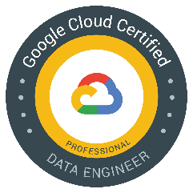
SAMEENA SHAIK
Generative AI Engineer
CONTACT: 971-(762)-0120
EMAIL: Sameenashaik1905@gmail.com

PROFESSIONAL SUMMARY:
- Senior Generative AI Engineer with 11+ years of experience designing and deploying production-grade AI systems, specializing in agentic workflows, enterprise RAG pipelines, and AI-powered automation solutions. Proven track record of building and shipping scalable GenAI applications using Claude, GPT-4, and LangChain frameworks, enabling intelligent assistants, knowledge retrieval systems, and AI-driven decision support tools.
- Hands-on expertise in developing AI agents, experimentation with emerging AI tooling, and deploying end-to-end solutions from concept to production using FastAPI, Kubernetes, and modern cloud platforms (Azure, AWS, GCP). Strong product mindset with the ability to operate in ambiguous environments, rapidly prototype solutions, and iterate based on user adoption and measurable business impact.
- Experienced in translating complex consulting and operational workflows into AI-enabled solutions through multi-agent orchestration, tool integrations, and prompt-driven automation.
- Implemented MLOps and CI/CD on GCP using Cloud Build, GitHub Actions, and Terraform, with model monitoring, drift detection, and governance.
- Deployed LLM-powered RAG applications via Vertex AI and LangChain, integrated into enterprise systems through FastAPI microservices.
- Hands-on experience with recommender systems, search platforms (ElasticSearch, Solr), and CI/CD integration for ML pipelines.
- Built agentic workflows using LangChain/LangGraph and experimented with Claude-based reasoning agents and Markdown tool-calling patterns for enterprise document workflows.
- Skilled in developing and operationalizing ML models across AWS, GCP, and Azure using platforms such as SageMaker, H2O, and DataRobot in advanced analytics, statistical modeling, and AI-driven solution development across logistics, banking, energy, agriculture, and media sectors.
- Experience working with Palantir-like enterprise data platforms and governed analytics environments, with strong focus on data governance, lineage, access control, and compliance.
- Extensive experience building GenAI systems using Claude (Anthropic), GPT-4, and LLaMA, including agentic workflows, RAG pipelines, and tool-enabled reasoning systems.
- Skilled in Natural Language Processing (NLP) for text classification, sentiment analysis, entity extraction, and document summarization using libraries like spaCy, NLTK, Hugging Face, and LangChain.
- Designed and deployed predictive models for fraud detection, churn prediction, demand forecasting, and customer segmentation using supervised and unsupervised learning techniques.
- Experience in integrating AI/ML solutions with enterprise applications, RESTful APIs, and data platforms like Snowflake, AWS Redshift, and Azure Synapse.
- Adept at working with large-scale data pipelines using tools like Apache Spark, PySpark, Airflow, and Kafka for batch and real-time processing.
- Developed and deployed models on cloud-based ML platforms including AWS SageMaker, Azure ML Studio, and Google Vertex AI.
- Implemented MLflow and DVC for tracking experiments and managing model lifecycles in CI/CD workflows using GitHub Actions and Jenkins.
- Built interactive dashboards and visualizations with Power BI, Tableau, and Plotly to support data-driven business decisions.
- Strong Python developer with deep experience in NumPy, Pandas, Scikit-learn, TensorFlow, PyTorch, and fast.ai.
- Collaborated with cross-functional teams including data engineers, MLOps, business analysts, and domain SMEs to deliver actionable insights at scale.
- Delivered LLM-powered assistants and internal copilots to automate research, document analysis, and helpdesk support at enterprise scale.
- Experience collaborating with cross-functional ML engineers, DevOps, and business teams to define MLOps workflows and best practices
- Demonstrated ability to lead project teams, mentor junior data scientists, and communicate results to both technical and non-technical stakeholders.
- Passionate about continuous learning and innovation in AI, with a focus on ethical AI practices, model explainability (SHAP, LIME), and responsible deployment.

Category | Tools & Technologies
Programming Languages | Python, SQL, PySpark, Bash, Java, Scala.
Machine Learning & AI | Scikit-learn, TensorFlow, Keras, XGBoost, MLflow, SageMaker, Databricks, H2O, DataRobot.
GCP Services | Vertex AI, BigQuery, Cloud Storage, Cloud Build, Cloud Run, Pub/Sub
Natural Language Processing (NLP) | NLTK, spaCy, Hugging Face Transformers, BERT, GPT-3/4, Cohere, Sentence-T5, OpenAI API
Generative AI & LLMs | LangChain, Anthropic Claude API, GPT-4, Azure OpenAI, Cohere
DevOps / IaC | Docker, Kubernetes (GKE), Terraform
Vector Search / Embeddings | Pinecone, Weaviate, ElasticSearch, FAISS, OpenAI Embeddings, Hugging Face Sentence Transformers, Solr.
Model Deployment / MLOps | Docker, Kubernetes (AKS), Airflow, MLflow, FastAPI, Flask, Azure DevOps, CI/CD Pipelines
Data Engineering & ETL | Apache Spark, Snowflake, Pandas, NumPy, AWS S3, Azure Data Factory, Feature Engineering
Cloud Platforms | AWS (S3, SageMaker), Azure (OpenAI, AKS), Azure ML, GCP
Databases | PostgreSQL, MySQL, Snowflake, ElasticSearch, Neo4j.
Data Governance & Security | Data governance, metadata management, lineage, role-based access control (RBAC), auditability, compliance-driven analytics
Business Intelligence / Dashboards | Tableau, Power BI, Streamlit, Seaborn, Matplotlib
MLOps Governance & Monitoring | Model monitoring, logging, drift detection, governance frameworks.

CERTIFICATION:

- AWS Certified Machine Learning – Specialty
- Google Cloud Professional Data Engineer
- Databricks Certified Data Engineer Associate
- TensorFlow Developer Certificate
- LangChain for LLM Application Development

PROFESSIONAL EXPERIENCE:

Senior MLOPS Engineer
Client: Neovia Logistics – TX
Duration: Apr 2023 – Present

Project Focus:

Leading GenAI solution design and deployment across logistics operations, driving efficiency in supply chain insights, document automation, and decision support with LLMs and vector-based retrieval.

Key Responsibilities:
- Architected multi-agent workflows using LangGraph DAG orchestration enabling tool calling and stateful reasoning.
- Designed enterprise-scale RAG framework using LangChain + Weaviate + Azure OpenAI.
- Built production LLM microservices with FastAPI + Kubernetes + CI/CD.
- Implemented prompt chaining and structured function-calling strategies.
- Designed scalable GenAI systems using GPT-4, Claude (Anthropic), and Cohere
- Architected agent orchestration DAGs (LangGraph) to coordinate multi-agent workflows, tool calling, memory, and state management for scalable GenAI applications.
- Architected a multi-tenant RAG framework using LangChain, Weaviate, and Azure OpenAI to power natural language interfaces for operational document search.
- Integrated LLM-powered assistants into Neovia’s ERP and warehouse management systems to allow contextual search over bills of lading, invoices, and maintenance logs.
- Led the development of vectorized data pipelines to convert legacy manuals, shipping logs, and contracts into embeddings for semantic retrieval.
- Developed secure APIs using FastAPI and Azure DevOps pipelines, enabling real-time LLM inference services integrated into client-facing dashboards.
- Partnered with cross-functional teams (data engineering, compliance, operations) to align GenAI outputs with logistics KPIs and data governance.
- Used SQL (MySQL) in production for feature extraction, analytics queries, and model training datasets across large-scale ML pipelines.
- Implemented CI/CD workflows for ML models ensuring reproducibility, scalability, and compliance with enterprise governance.”
- “Developed monitoring and governance frameworks for ML model lifecycle management, ensuring compliance and audit readiness.”
- Devised prompt chaining and function-calling strategies using LangChain to generate logistics summaries, anomaly reports, and carrier performance reviews.
- Enabled robust feedback loops and usage analytics using Databricks and Power BI to track GenAI adoption and continuously refine prompt templates.
- Led cost optimization efforts by experimenting with multiple LLM providers (OpenAI, Cohere, Azure) and adjusting inference strategies based on workload.
- Guided internal teams through GenAI literacy sessions, use case identification workshops, and AI safety reviews to drive responsible adoption.
- Created IaC deployments for GenAI microservices using Terraform and Kubernetes (AKS) ensuring high availability and disaster recovery compliance.
- Acted as primary solution architect and technical lead for Neovia’s enterprise-wide GenAI transformation roadmap, reporting directly to AI program sponsors.

Environment: Python, LangChain, OpenAI GPT-4, Cohere, Azure OpenAI, Weaviate, Vector DBs, FastAPI, Azure DevOps, Databricks, Terraform, Kubernetes (AKS), Power BI

Senior Generative AI Engineer / MLOPS Engineer
Client: Marathon Petroleum – OH
Duration: Oct 2020 – Mar 2023

Project Focus:

Led GenAI initiatives to automate internal documentation retrieval, streamline compliance processes, and enhance knowledge discovery using LLMs and Retrieval-Augmented Generation (RAG).

Key Responsibilities:
- Developed enterprise RAG pipelines using LangChain and GPT models for compliance knowledge retrieval.
- Implemented LLM observability and evaluation pipelines to monitor hallucination and response quality.
- Built predictive analytics pipelines for plant operations using Python, SQL, and Spark.
- Implemented monitoring, version control, and MLOps best practices for enterprise deployment.
- Developed enterprise-grade RAG pipelines integrating GPT-3 with internal policy documents, engineering manuals, and safety reports to enable natural language querying.
- Deployed LLM-powered RAG applications on AWS SageMaker, integrating vector databases and FastAPI services with containerized inference endpoints for scalable, production-grade GenAI deployment. Fine-tuned LLMs on proprietary petrochemical compliance data to improve relevance and factual accuracy in GenAI responses.
- Created internal GenAI chatbots with LangChain and OpenAI APIs to assist plant engineers and compliance officers in retrieving critical operational data.
- Implemented robust prompt engineering strategies to guide LLM behavior, reduce hallucinations, and align responses with safety protocols.
- Collaborated with knowledge management teams to identify high-value content sources and curate RAG corpus pipelines from unstructured PDFs and scanned docs.
- Containerized GenAI applications using Docker and deployed them on Azure Kubernetes Service (AKS) with CI/CD pipelines for continuous model updates.
- Set up observability and feedback loops with MLflow to monitor LLM usage, output confidence, and user satisfaction metrics.
- Evaluated and benchmarked MLOps frameworks including MLflow, Kubeflow, and Ray for large-scale enterprise deployment.”
- Designed observability pipelines for ML models, integrating monitoring, logging, and governance practices.”
- Ran internal A/B tests comparing GenAI search vs. legacy portal queries, showing significant improvements in search time and answer relevance.
- Partnered with legal and compliance to enforce LLM guardrails, PII filtering, and auditing for enterprise-grade usage and trust.
- Contributed to Marathon’s AI Center of Excellence by hosting internal GenAI bootcamps and mentoring junior engineers in LLM integration.

Environment: Python, Hugging Face Transformers, GPT-3, LangChain, Pinecone, OpenAI API, FastAPI, Streamlit, Docker, Azure ML, MLflow, ElasticSearch

Senior Machine Learning Engineer
Client: Netflix – CA
Duration: Jun 2017 – Sep 2020
Project Focus:
Led ML initiatives to power Netflix’s content recommendation system and viewer behavior analytics. Delivered scalable pipelines and personalized models that enhanced user engagement and reduced churn.
Key Responsibilities:
- Designed and deployed collaborative filtering and deep learning-based recommender systems to personalize movie and series suggestions for millions of users.
- Designed recommender systems using TensorFlow, PySpark, and large-scale streaming data.
- Built and deployed end-to-end ML workflows on Airflow and SageMaker.
- Built and productionized ML models using TensorFlow and Keras to predict user watch likelihood, completion rate, and content affinity.
- Leveraged PySpark and Snowflake to process petabyte-scale viewing logs, ensuring robust data pipelines for model training and A/B testing.
- Architected end-to-end ML workflows using Apache Airflow, automating feature extraction, training, validation, and deployment.
- “Automated ML workflows with Airflow and SageMaker; contributed to CI/CD pipelines for continuous model delivery.”
- Conducted hyperparameter tuning and model selection through SageMaker experiments, improving recommendation precision and recall metrics.
- Developed real-time inference APIs using Flask and deployed them in Docker containers managed by Kubernetes clusters.
- Designed and deployed large-scale recommender systems leveraging collaborative filtering and deep learning, improving personalization and engagement metrics.”
- “Integrated recommendation models into real-time streaming architecture with Airflow, SageMaker, and Kubernetes.”
- Partnered with product managers and data scientists to translate business goals (e.g., increased binge-watching, content discovery) into ML use cases.
- Implemented model monitoring and drift detection pipelines to ensure system health post-deployment in a dynamic streaming environment.
- Delivered offline evaluation reports and online A/B test analysis to guide product strategy and validate model effectiveness.
- Worked with engineering teams to ensure low-latency and high-availability for ML services powering homepage and category ranking.
- Participated in cross-functional review sessions and shared learnings in internal ML guilds, promoting model reusability and best practices.
- Played a key role in migration of legacy batch models to real-time recommendation infrastructure using streaming data pipelines.
Environment: Python, PySpark, TensorFlow, Keras, Airflow, AWS SageMaker, Snowflake, Docker, Kubernetes, Git

Senior NLP Data Scientist
Client: Bank of America – NC
Duration: Jun 2015 – May 2017

Project Focus:
Led the design and deployment of NLP-based solutions to extract insights from financial documents and customer interactions, helping improve risk assessment, fraud detection, and service quality.

Key Responsibilities:
- Developed NLP pipelines to process and analyze large volumes of unstructured text from customer emails, call transcripts, and financial reports.
- Built NLP pipelines for unstructured financial data to extract actionable insights.
- Built named entity recognition (NER) models using spaCy and rule-based techniques to extract sensitive entities like account numbers, SSNs, and financial products.
- Designed topic modeling workflows (LDA, NMF) to uncover recurring themes in support tickets and escalate high-risk issues.
- Created sentiment analysis tools using supervised learning (SVM, logistic regression) to gauge customer satisfaction and trigger follow-ups.
- Collaborated with the compliance and fraud prevention teams to detect suspicious language patterns in transactional communication data.
- Exposure to financial services compliance and risk management use cases including fraud detection, customer insights, and regulatory workflows.”
- Integrated word embeddings (Word2Vec, GloVe) into downstream models to improve contextual understanding of domain-specific terms.
- Utilized Apache Spark for distributed processing of millions of customer communications and reduced NLP inference latency.
- Conducted EDA and linguistic feature engineering to support the training of text classifiers with measurable accuracy improvements.
- Built visualization dashboards using Python (matplotlib, seaborn) and shared reports to business units for real-time monitoring.
- Partnered with data engineering to automate ETL pipelines from AWS S3 to NLP model endpoints and reporting layers.
- Participated in annotation guideline development and oversaw offshore labeling teams to ensure data quality for supervised training.
- Mentored junior analysts on NLP workflows, model evaluation techniques, and ethical considerations in text mining.

Environment: Python, NLTK, spaCy, Scikit-learn, TensorFlow, SQL, Apache Spark, AWS S3, Jira

Data Scientist
Client: John Deere – IL
Duration: Jun 2014 – May 2015
Project Focus:
Supported the development of predictive maintenance models for agricultural machinery by leveraging equipment sensor data and statistical modeling techniques.
Key Responsibilities:
- Contributed to the design and training of machine learning models to forecast mechanical failures in tractors and harvesters.
- Developed predictive maintenance models on sensor data for industrial machinery.
- Performed exploratory data analysis (EDA) on raw telemetry data using Python libraries to identify anomalies and operational trends.
- Assisted in building classification models (e.g., decision trees, random forests) to detect early warning signs of component failure.
- Wrote SQL queries to extract structured maintenance records and linked them with real-time sensor data for supervised learning.
- Cleaned and preprocessed time-series data from onboard vehicle sensors, ensuring model readiness and data consistency.
- Created simple Tableau dashboards to present machinery uptime, usage cycles, and model predictions to internal stakeholders.
- Shadowed senior data scientists to understand model evaluation metrics such as precision, recall, and ROC-AUC.
- Contributed to model validation by comparing predictions with historical failure events and generating confusion matrices.
- Helped automate data ingestion pipelines using Python scripts to fetch and preprocess daily sensor logs from AWS S3.
- Documented findings and presented initial insights during sprint reviews and retrospectives with product managers.
- Participated in agile ceremonies, learning how to translate user stories into actionable data science tasks.
- Gained hands-on exposure to end-to-end ML development — from data wrangling and feature engineering to reporting and stakeholder demos.

Environment: Python, Pandas, NumPy, Scikit-learn, SQL, Tableau, Jupyter, AWS S3

